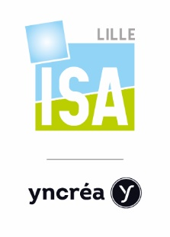 | LEARNING AGREEMENT  Academic year 2017-2018

Please check our website www.isa-lille.com.
Admission will not be granted unless this section is fully completed

Student's name :
Sending institution:
Country:
Field of study:
Number of higher education study  years prior to departure abroad: | Diploma/degree you are currently studying:

INTENDED STUDY PROGRAM

Course Title | Period (S1/S2) | Credits

I agree to take all exams related to the course | Students’ signature : | Date :

I hereby approve the above plan of study/learning agreement: | Sending Institution  co-ordinator’s signature : | Date:

I hereby approve the above plan of study/learning agreement: | Receiving Institution  co-ordinator’s signature: | Date:

Application deadlines: May 1st (Semester 1/Academic year) – November 1st (Semester 2)

