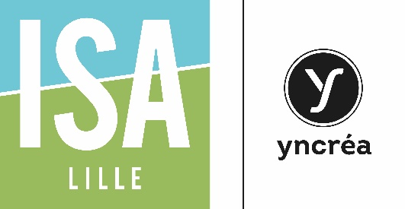 | LEARNING AGREEMENT  Academic year 2017-2018  Please check our website www.isa-lille.com.  Admission will not be granted unless this document is fully completed

Student's name :
Sending institution:
Country:
Field of study:
Number of higher education study  years prior to departure abroad: | Diploma/degree you are currently studying:

INTENDED STUDY PROGRAM

Course Title | Period (S1/S2) | Credits

I agree to take all exams related to the course | Students’ signature : | Date :

I hereby approve the above plan of study/learning agreement: | Sending Institution coordinator’s signature: | Date:

I hereby approve the above plan of study/learning agreement: | Receiving Institution coordinator’s signature: | Date:

Application deadlines:
Fall Semester/Academic Year – April 30
Spring Semester – October 31

