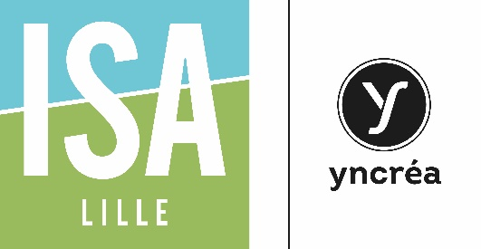 | APPLICATION FORM FOR ADMISSION  EXCHANGE PROGRAM  ACADEMIC YEAR 2018-2019 | (photograph)
ISA Lille
48 Boulevard Vauban
59014 LILLE cedex - FRANCE
Head of International Relations Office: Ms Florence MALAISE
+33 (0)3 28 38 46 10
Isa.international@yncrea.fr

This form must be filled in completely. Type or write very clearly (in black ink).
Semester 1 (Fall)  Semester 2 (Spring)  Semesters 1 & 2 (one academic year)  Double degree  Expected arrival date: …………………………………….  Expected departure date: ……………………………….. |  |  |  |  |  | Application deadline : April 30th  Application deadline : October 31st  Application deadline : April 30th  Application deadline : April 30th
Number of years of study prior to departure : |  |  |  |  |  |  | Date of birth (D,M,Y) :  Place of birth:
Last name:
First name: |  |  |  |  |  |  | Gender: Female 􀂅  Male 􀂅
Nationality: |  |  |  |  |  |  | Mother tongue:
Current address:  :………………………………………………………………………………………………  City: ……………………………………………………………….…  Postal code: ………………………... |  |  |  |  |  |  | Current address  is valid until :
Tel: |  | Fax: |  |  |  |  | E-Mail:
Home University:  (Full name) |  |  |  |  | Socrates code for  European Universities:
Contact person at home University:
(name, address, tel, fax, e.mail)
Language skills:  French :  English :  Other : …………………. | Excellent  Excellent  Excellent  Excellent  Excellent  Excellent |  | Advanced  Advanced  Advanced  Advanced  Advanced  Advanced |  |  |  |  | Intermediate (oral)  Intermediate (written)  Intermediate (oral)  Intermediate (written)  Intermediate (oral)  Intermediate (written)
Type of Exchange Programme:  ERASMUS  Other (please specify): |  |  |  | Bilateral institutional agreement

